# Summarizing Dates

This document includes the question, the solution, and a breakdown of the code provided in the screenshot.

## Uploaded Screenshot

Below is the screenshot of the task:

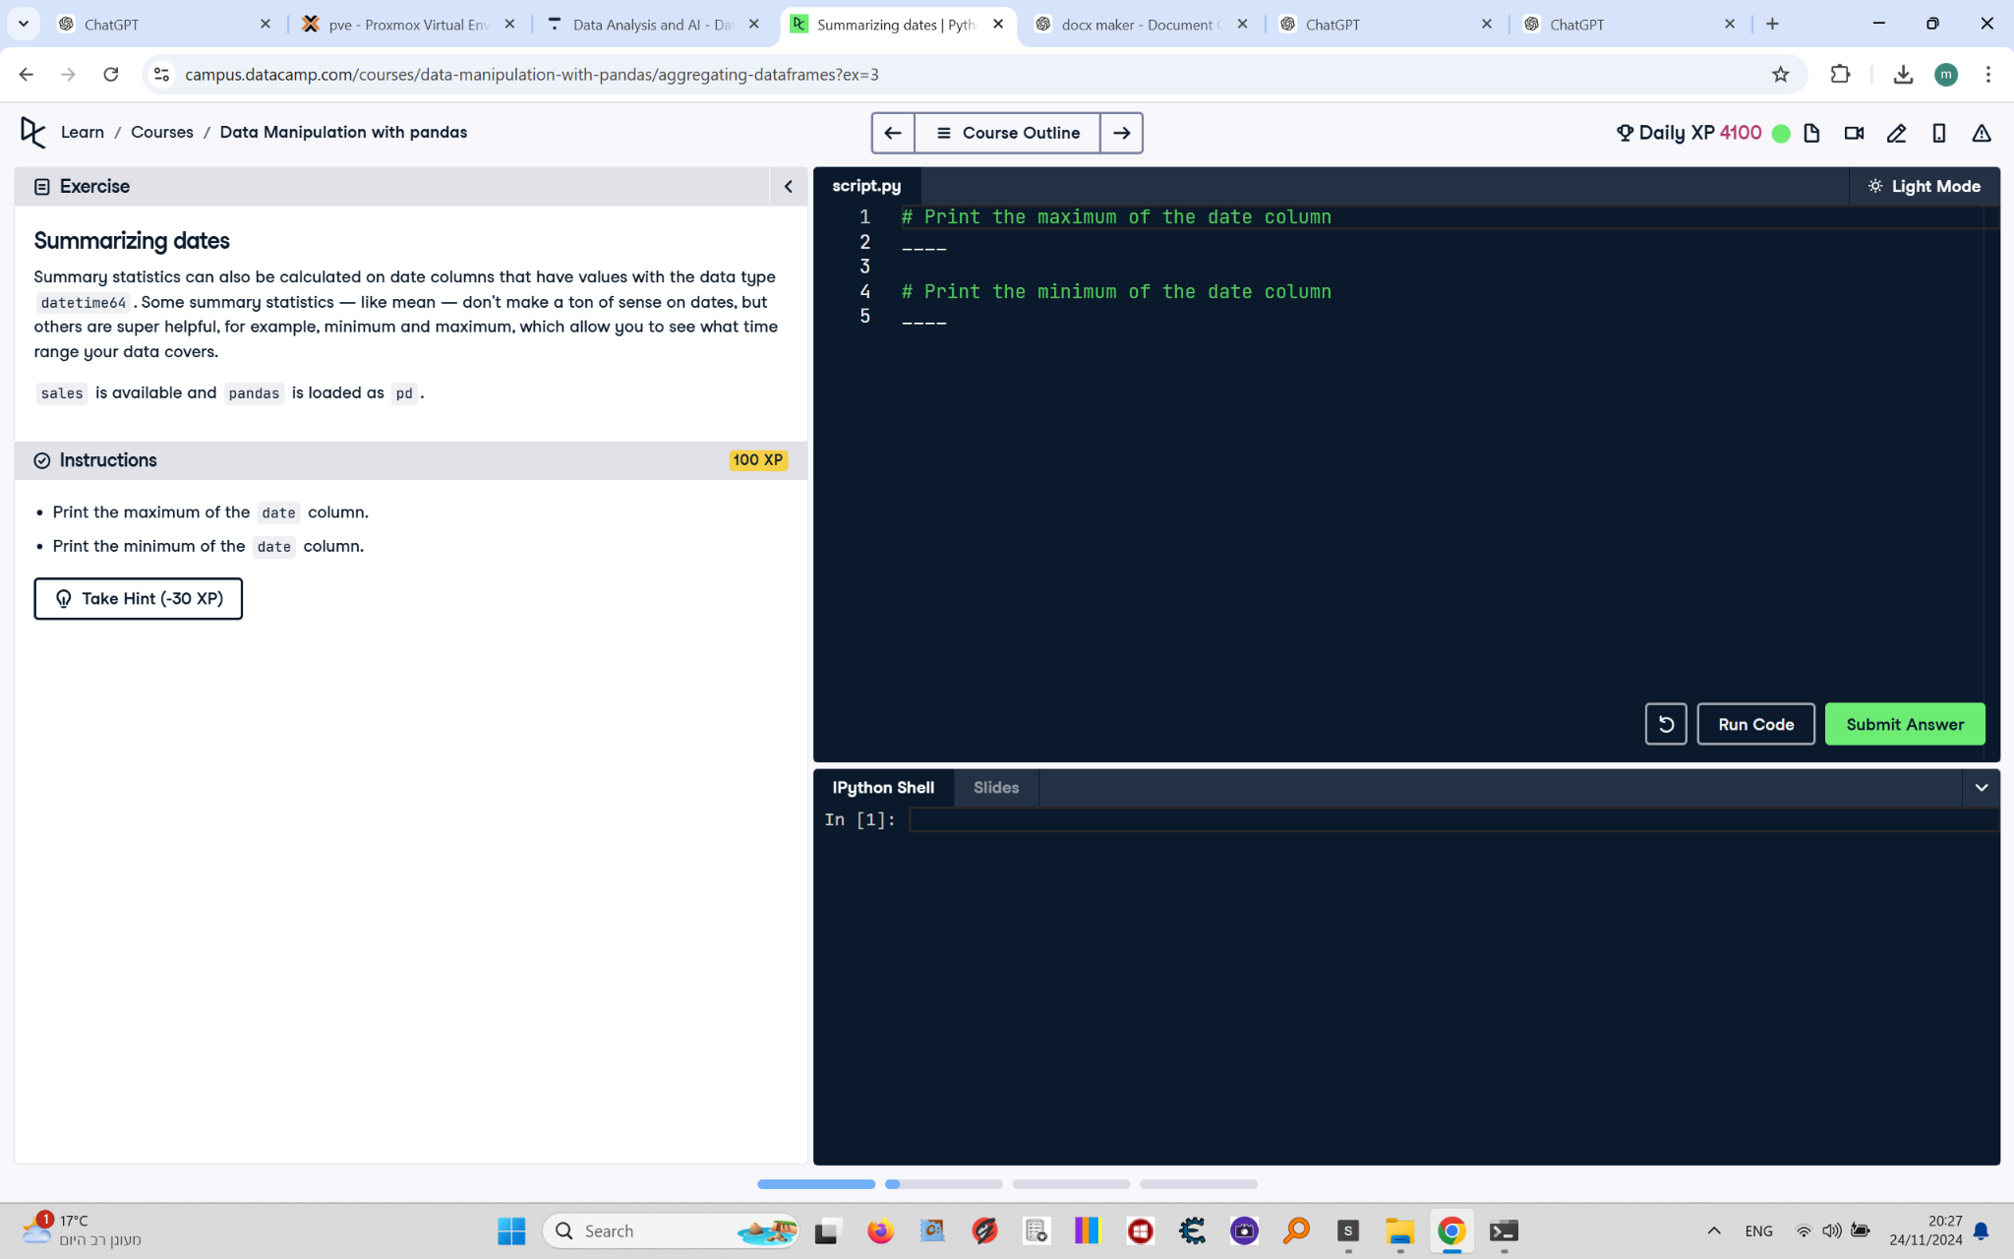

## Question

1. Print the maximum of the `date` column.  
2. Print the minimum of the `date` column.

## Answer

# Print the maximum of the date column  
print(sales['date'].max())  
  
# Print the minimum of the date column  
print(sales['date'].min())

## Code Explanation

# Explanation of the code:

1. `sales['date'].max()`: Calculates the latest (maximum) date in the `date` column of the `sales` DataFrame.

2. `sales['date'].min()`: Calculates the earliest (minimum) date in the `date` column of the `sales` DataFrame.

These calculations are helpful to determine the range of dates covered in the dataset.